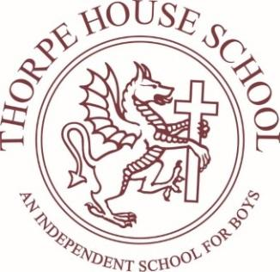

SCHOOL ASSISTANT
Line Manager: Senior Deputy Head

About the Role
Thorpe House School is seeking an enthusiastic, energetic and reliable School Assistant to join our vibrant school community.
This is an exciting opportunity for someone considering a future career in education, sport, pastoral care, childcare or school operations. The role provides excellent hands-on experience across all areas of school life and is ideal as a stepping stone into teaching, coaching or wider educational support roles.
The successful candidate will become an important part of the daily life of the school, supporting pupils and staff across academic, pastoral, sporting and operational areas.
No two days are the same, and the role offers valuable experience working within a busy and supportive independent school environment.

Key Responsibilities
The School Assistant will support the wider life of the school through a range of duties, including:

Pupil Support & Supervision
- Running Breakfast Club each morning from 7:30am to 8:20am.
- Escorting Prep School pupils safely to the Lower School site.
- Supervising playground, breaktime and lunchtime duties.
- Supporting pupils during lessons where appropriate.
- Assisting Learning Support pupils as directed by staff.
- Supervising pupils when teaching staff are absent.
- Supporting pupils during school events, activities and educational visits.

Classroom & School Life Support
- Assisting teachers within the classroom environment.
- Working with a pupil 1 to 1 for 3 hours a day.
- Supporting Forest School activities and outdoor learning.
- Accompanying staff and pupils on trips and visits where appropriate.
- Helping with the organisation and smooth running of key school events.

Administrative Support
Supporting the School Office with general administrative duties, including:
- Photocopying and laminating.
- Filing and shredding.
- Preparing school materials and prospectuses.
- Delivering messages and items across the school.
- Supporting communication and distribution tasks.
- Assisting with post and deliveries.

Operational & Facilities Support
- Supporting the Facilities Manager with practical tasks around the school site.
- Assisting with the maintenance and operation of the swimming pool.
- Helping with moving equipment and setting up for events and activities.
- Assisting with general site duties requiring additional support.

What We Are Looking For
We are looking for someone who:
- Enjoys working with children and young people.
- Is enthusiastic, positive and approachable.
- Has strong communication and teamwork skills.
- Is organised, flexible and willing to get involved in all aspects of school life.
- Demonstrates initiative and a willingness to learn.
- Has an interest in education, sport, coaching or pastoral support.
Previous school experience is not essential, although experience working with children or young people would be beneficial.

Why Join Thorpe House?
This role offers:
- Excellent experience for those considering a career in teaching or education.
- Opportunities to work closely with experienced school staff and leaders.
- Involvement in sport, trips, events and wider school life.
- A supportive and welcoming school community.
- A varied and rewarding role where you can make a genuine difference to pupils’ daily experiences.
This job description is not intended to be exhaustive and may be amended in consultation with the post holder to meet the school's evolving needs.

