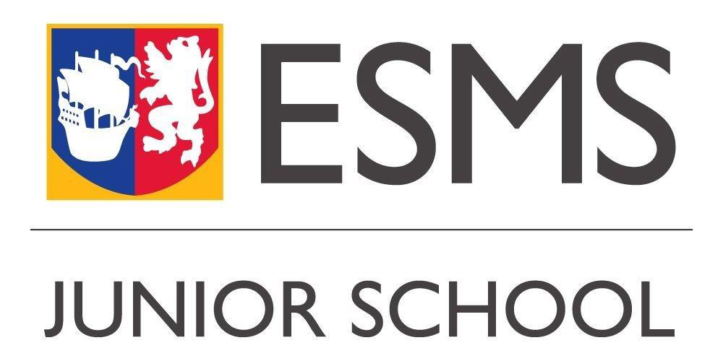
e-Plus Receptionist
(Permanent, Part time, Term time)
Purpose of Job
The e-Plus Receptionist provides an efficient, friendly and welcoming service to all of our families who use e-Plus. They are required to ensure the secure and safe collection of our youngest children in collaboration with colleagues and required to manage the telephone and undertake various administrative tasks assigned by the e-Plus Manager.
Accountability
The e-Plus Receptionist is accountable to the e-Plus Manager.
Authority
The e-Plus Receptionist has authority as delegated by the e-Plus Manager.
Key Relationships
The e-Plus Receptionist works closely with the e-Plus Administrator and e-Plus manager to ensure that there is a shared and co-ordinated approach to all the work which takes place at Reception.

The Post:
Key Responsibilities
Vision and Values
- Promotion of ESMS values of Kindness, Confidence, Resilience, Integrity, and Curiosity in all aspects of the role.
- Promotion of role modelling behaviours that align with the three school pillars of Ambition, Innovation, and Community.
Fostering an environment that supports the development of these values among students and staff.
Working with Others
- Compliance with all ESMS policies and procedures
- Treating people fairly, with dignity and respect to maintain a positive school culture
- Ensure effective planning, delegation and support of responsibilities
- Developing a culture of high expectations for all and taking action when performance does not live up to these
- Taking responsibility for personal development, both personally and of team members.

Community
- Positive relationships with parents and the wider ESMS community
- Communicating clearly with parents and carers to engender a climate of mutual respect
- Working in collaboration with other independent schools to promote effective initiatives and share good practice.

Safeguarding

- Adhering to the principles and guidelines of “Getting It Right For Every Child” (GIRFEC) to ensure every child receives timely and appropriate support with their welfare as paramount.

Supporting the leadership of the Schools/ Duties and Responsibilities
- To be a friendly, welcoming and supportive ‘first voice/face’ for all children and parents at New Ravelston.
- To accept, alter and amend bookings and staffing information, as and when necessary
- To maintain an accurate list of messages and to ensure that these are forwarded and dealt with effectively and quickly.
- To process emails sent from parents and process or forward them, as appropriate.
- To ensure, as far as is reasonable and practical, in collaboration with other colleagues, the safe collection of all children using the services across both sites.
- To complete any other administrative duties as may be reasonably expected by the e-Plus Manager.
- To issue School Post communications to parents, as and when required.

Person Specification
 | Essential | Desirable
Experience | - Previous experience of working at a busy reception | - Understanding of ESMS structures and procedures  - Previous experience of working in a school or educational setting
Skills/ Abilities/  Qualifications | - Proficient in the full Microsoft Office package, specifically Word and Excel  - Excellent communication skills (orally and in writing)  - Experience of building professional relationships with external and internal stakeholders  - Excellent interpersonal and communication skills (orally and in writing), with an ability to handle sensitive and confidential information  - Ability to multi-task and prioritise own workload with good attention to detail  - Independent, self-motivated and organised, with an ability to work as part of a team | - Experience of SharePoint and PASS  - Experience of database administration
Personal Attributes | - High professional and personal standards  - Workplace flexibility and a willingness to adapt to change with regards to how and when work is progressed  - Commitment to ESMS values | - Commitment to continuous professional development

Personal Qualities
- Dealing with every situation calmly and professionally
- A desire for fairness, dignity, and respect in every interaction
- Excellent oral and written communication skills
- Excellent self and time-management skills
- Active listening
- The highest level of personal integrity

REMUNERATIONS AND OTHER CONSIDERATIONS
As an equal opportunities employer, ESMS is committed to the equal treatment of all current and prospective employees and does not condone discrimination on the basis of age, disability, sex, sexual orientation, pregnancy and maternity, race or ethnicity, religion or belief, gender identity, or marriage and civil partnership. We aspire to have a diverse and inclusive workplace and strongly encourage suitably qualified applicants from a wide range of backgrounds to apply and join ESMS.
The post This is a permanent, part time, term time position available immediately (subject to satisfactory pre-employment checks).
Hours of Work The hours of work will be part-time, 16 hours per week (Monday to Thursday from 2.00 pm to 6.00 pm) however additional hours may be available.
Salary As this role is part time and term time only, the pro rata salary range is £8,236 - £8,783 per annum, which is on the ESMS Support Staff Salary Scales C, dependent on experience and qualifications.
Holiday Annual leave will be a paid allowance in the annual salary as this is a term time only contract. All holidays will be taken during the school holidays.
Location The postholder will be based mainly on the ESMS Junior School site at Ravelston.

Eligibility ESMS is unable to sponsor the employment of international workers in this role. International applicants will therefore be unable to apply for and secure a Skilled Worker visa. The successful candidate will only be able to take up this role if they can demonstrate an alternative right to work in the UK.
Pension Candidates will be enrolled automatically/entitled to be enrolled into the Merchant Company Stakeholder Pension Scheme.
Staff Benefits Staff are offered a range of benefits including: use of the Schools’ swimming pool and fitness room outside school hours and membership of the ESMS Discount and Benefits Scheme, including a range of discounts at 130,000 retail and entertainment locations, as well as access to our EAP provider, Care First.

The closing date for applications is 12pm on Wednesday 25 September. We anticipate interviews will be held week commencing 30 September.

