**ROLE SPECIFICATION**

**EARLY YEARS PRACTITIONERS**

**Full and Part time roles available**

**Context - our school**

Morrison’s Academy is a friendly, family-oriented independent day school in the heart of Perthshire. Our long tradition of academic success in boys and girls from 2 to 18 continues today with a contemporary Scottish curriculum and a programme of independent, child-centred learning that builds emotional intelligence, creativity and life skills, and encourages every child to strive for the highest.

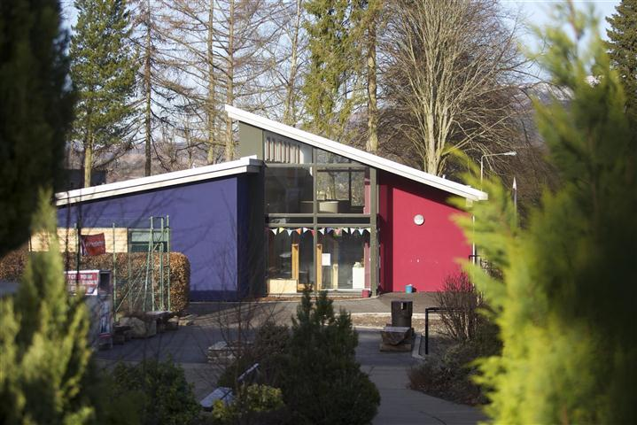

Our new Early Years team is friendly, dynamic and enthusiastic about the growth of the nursery and the ways that adults can support children to play and discover wondrous things whilst playing inside and outside. Supported by internationally renowned, Dr Claire Warden, the team are exploring planning through Floorbooks and ways to embrace nature pedagogy in the philosophy of the setting.

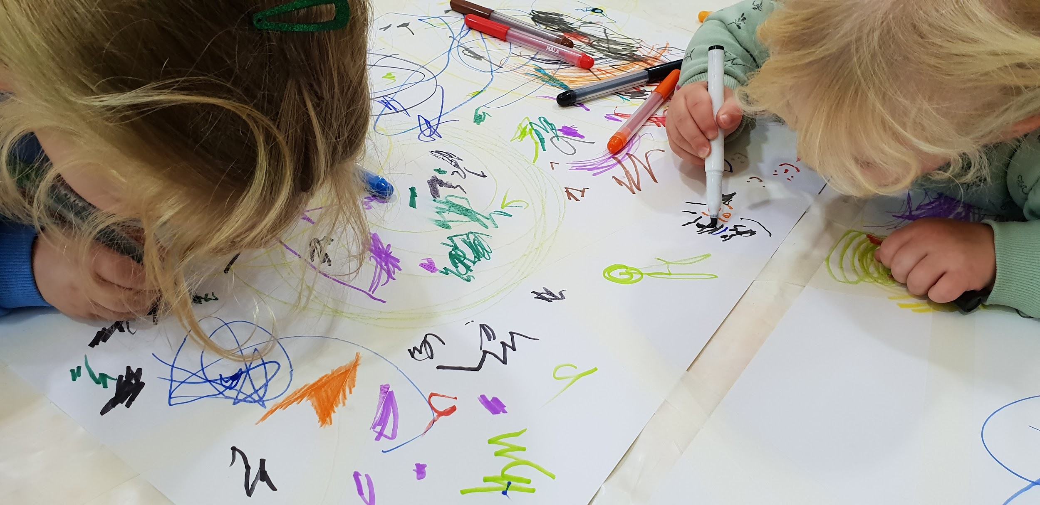

**Context - our families and team**

Crieff is a vibrant community in a beautiful part of the country, at the gateway to the Highlands and in easy reach of the central belt. The Morrison’s Academy family is friendly and progressive; we have high expectations of one another and the confidence to encourage innovation.

We are committed to the career-long professional learning of all our staff. Our programme of Performance Reviews and generous CPD budget promotes continuous improvement within and beyond the classroom, with plenty of scope for colleagues to pursue interests and specialisms.

**Context - our campus**

The School’s main campus is located in the centre of Crieff and comprises a mixture of historic (our magnificent original buildings dating from 1860) and modern buildings. Our cutting-edge Nursery, recently renovated library, upgraded science labs and new on-site café set the standard for excellence.

The nursery is an integral part of the school and has access to all the facilities making it a very engaging space to work. Children choose to listen to older children play instruments, enjoy the gym for movement, choose the outdoor stage to dance and explore sand and water in our new materials zone in the garden. Morrison’s Academy is committed to ongoing development and modernisation which applies to being sector leading in our spaces, interactions and experiences.

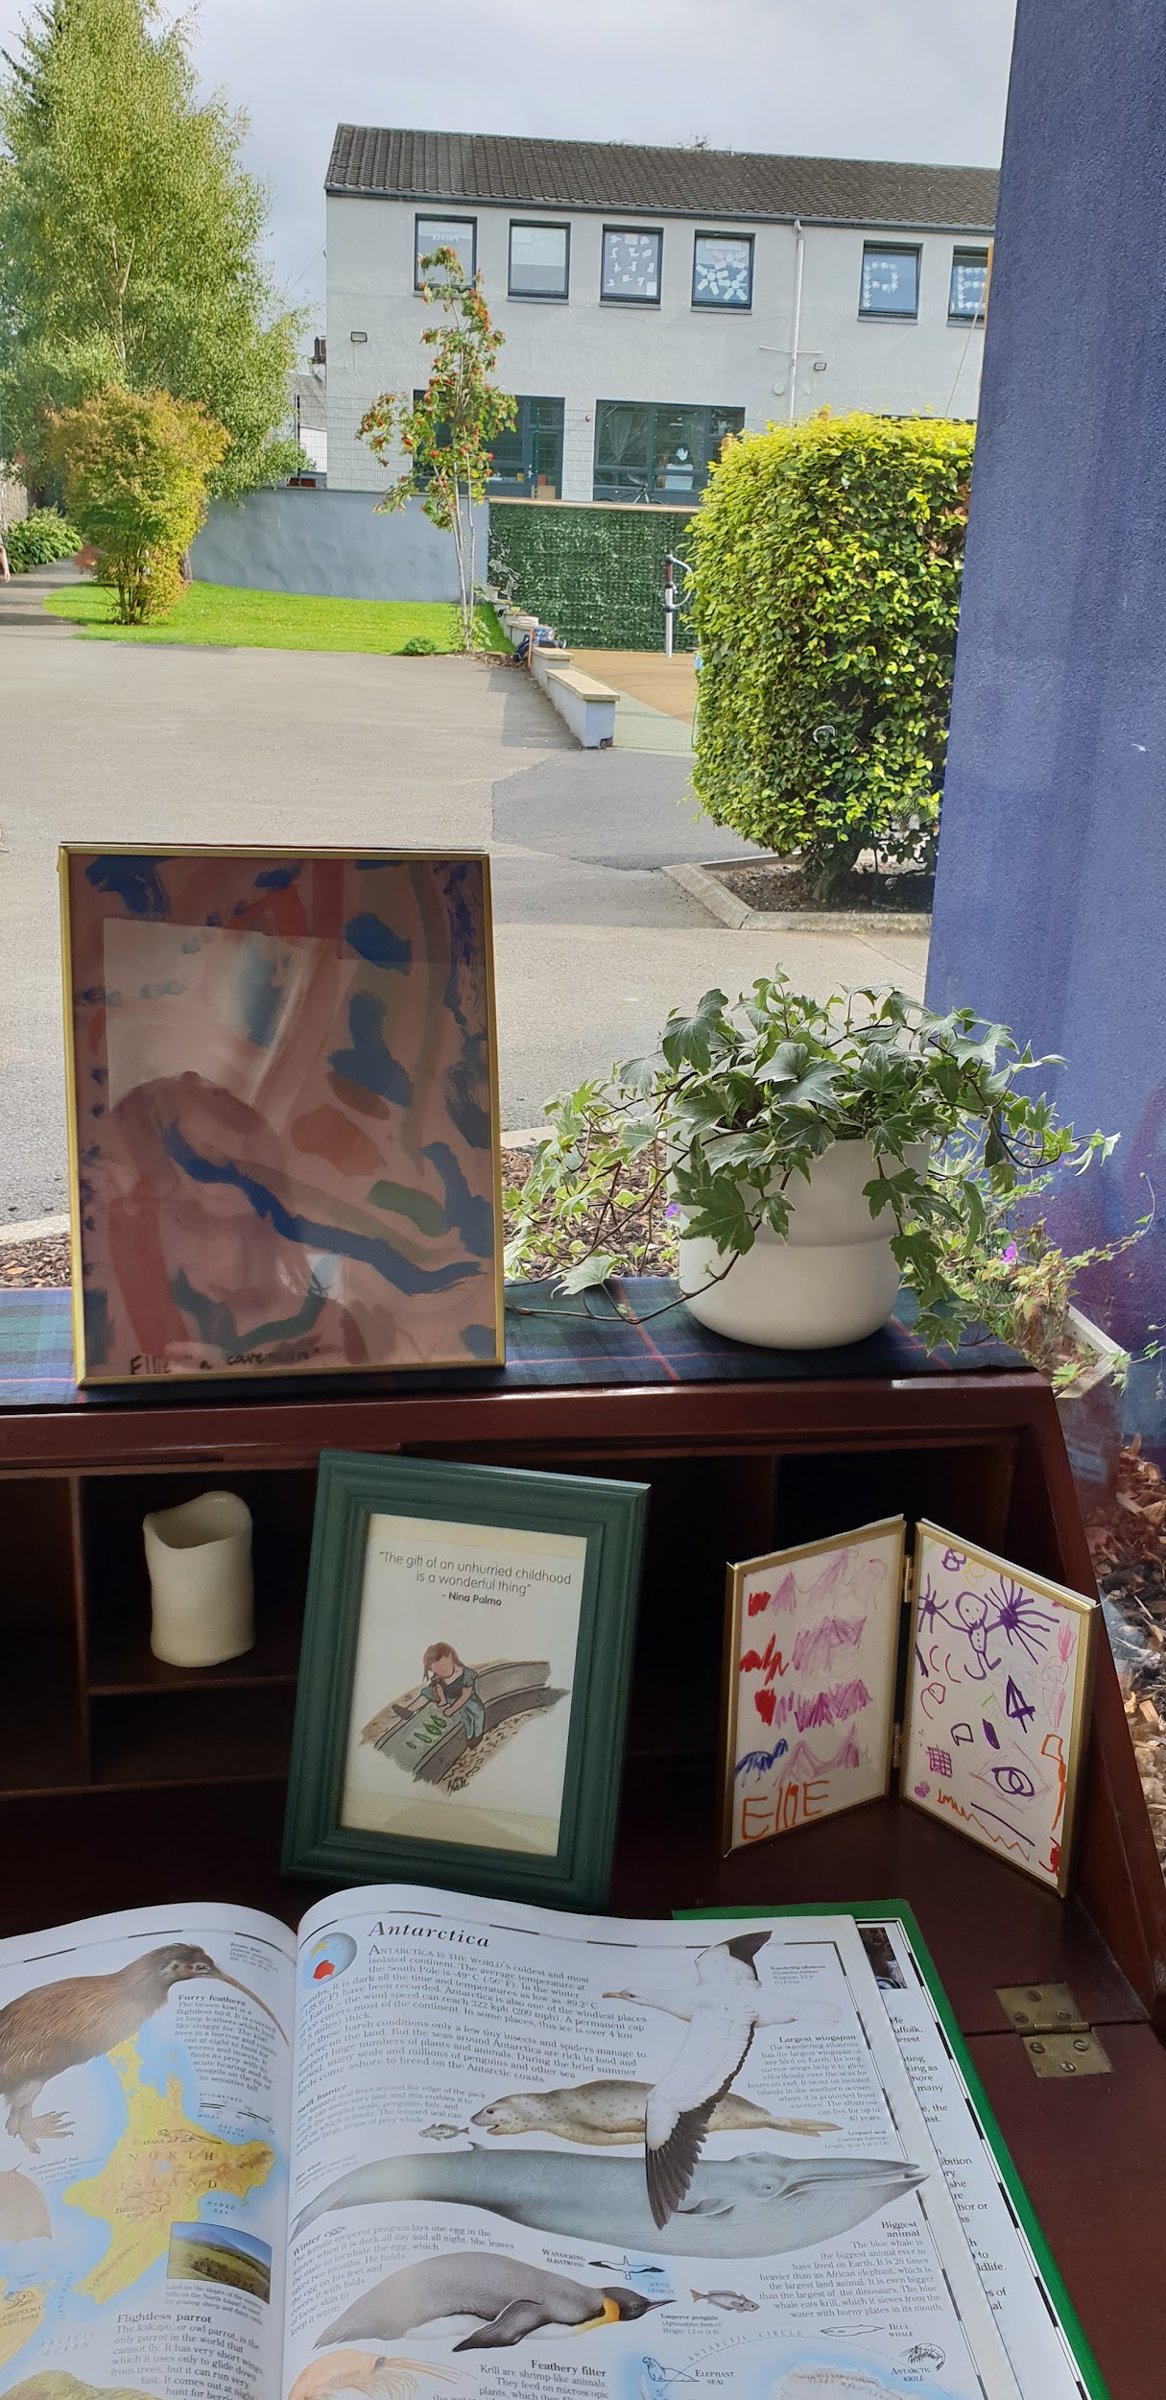

**EARLY YEARS PRACTITIONER**

# Role

The post holder will promote a stimulating and caring learning environment for children within our Early Years setting. This is an exciting opportunity to join an established Nursery and help shape its future as a thriving indoor / outdoor nursery focused on personalised learning. To be successful the post holder should be passionate about Early Years education.

**Qualifications**

**Essential**

* Passionate about Early Level Education
* Be GTCS registered or SSSC registered or be eligible for registration

**Desirable**

* Experience and interest in child centred, play based pedagogy
* Positive attitude to being outside
* Experience working within an Early Years setting
* IT literate
* Hold a full driving licence
* SVQ3 qualification

**Reports To**

Head of Primary and the Rector

# Hours of Work

# There is both a full time and part time role within the Nursery.. The post holder will also be required to attend Open Mornings, Sports Day and other ad-hoc days out with the normal working week.

# Salary Scale

This will be dependent on experience.

**Early Years Practitioner the principal tasks will be to:**

1. Work as a member of the Early Years Team whilst establishing strong and effective relationships with the children, staff and parents.
2. Demonstrate high standards of care and education; promoting high standards within the Early Years setting in respect of the environment, resources and experiences offered to children.
3. Have a sound knowledge of child development and ensure that all children receive rich and stimulating experiences appropriate to their age and stage of development and their individual needs.
4. Deliver high quality, differentiated lessons and learning experiences across the Early Years curriculum and in line with the School’s strategic plan.
5. Promote learning and celebrate achievement through stimulating and varied displays.
6. Maintain a culture of self evaluation and reflective practice throughout the Early Years.
7. Observe children accurately, record all assessments and observations and use these observations, in consultation with other staff, to plan appropriate learning experiences for the children.
8. Promote high standards of behaviour and discipline amongst the children, safeguarding their health and safety.
9. Be able to contribute his/her own skills and interests in music, drama, movement, art, literature and environmental studies for the development of the children as appropriate.
10. Be responsible for the children on organised outings.
11. Carry out short, medium and long term planning for the children and ensure all this is recorded and kept up to date in line with Perth & Kinross Council guidelines.
12. Participate in professional staff development opportunities within the school and/or by attendance at in-service courses and ensuring that all relevant certificates are valid and up-to-date (eg First Aid) and to comply with SSSC requirements.
13. Comply with individual responsibilities imposed by the Health and Safety at Work Act 1974 and the Management of Health and Safety at Work Regulations (1999) and to cooperate with Management to promote a positive attitude towards health and safety at work, taking all reasonable practical steps to prevent personal injury or injury to others.

This role specification is intended to convey a broad outline of the position and responsibilities of the Early Years Practitioner. It is not definitive and will be mutually reviewed from time to time as part of the process of personal review and development.