

**ROLE SPECIFICATION**

**PRIMARY SCHOOL TEACHER**

**TEMPORARY, MATERNITY COVER**

**Context**

Morrison’s Academy is a friendly, family-oriented day school in the heart of rural Perthshire. Generations of Morrisonians have benefited from the school’s rich blend of academic, artistic and sporting experiences, going on to make their mark on the world as Olympic athletes, groundbreaking scientists, award-winning actors, adventurers, politicians and professionals. Our long tradition of academic success in boys and girls from 2 to 18 continues today with a contemporary Scottish curriculum and a programme of independent, child-centred learning that builds emotional intelligence, creativity and life skills, and encourages every child to strive for their highest. Our school roll of over 550 young people and over 120 staff are all active members of the local community, and we all know and support one another, working together as a team to put pupils and parents first. We embody this culture in everything we do, delivering excellence in teaching and nurturing the individual to encourage every child to flourish.



The school is committed to our programme of ongoing development and modernisation. Our cutting-edge Nursery sets the standard for excellence at our main campus in the centre of Crieff, and our newly-completed all-weather pitch allows year-round matches and training at our off-site outdoor sports campus. There is also a detailed plan of redevelopment and restoration to the school’s magnificent original buildings, erected when the school was founded in 1860.

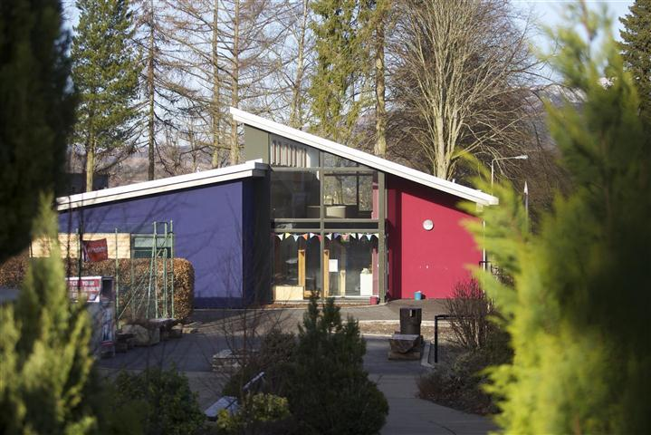

Our young people are a delight to teach, and the staff and governors are helpful and supportive. Crieff is a vibrant community in a beautiful part of the country, at the gateway to the Highlands and in easy reach of the Central Belt. The Morrison’s family is friendly and progressive; we have high expectations of one another and the confidence to encourage innovation.



We are committed to the career-long professional learning of all our staff. Our programme of Performance Reviews and generous CLPL budget promotes continuous improvement within and beyond the classroom, with plenty of scope for colleagues to pursue interests and specialisms.

**TEACHER OF PRIMARY**

**Role**

The post-holder will be on a temporary contract, covering a maternity leave. They will be expected to teach a class following the appropriate curriculum guidelines and policies of the Primary School. It is a requirement that they will also make a contribution to the programme of co-curricular activities.

**Qualifications**

Essential

* A degree-level qualification relevant to the teaching of Primary
* A PGCE qualified NQT or equivalent will be considered
* Strong interpersonal skills
* Candidates should be GTC Scotland registered, or eligible for registration
* Competent in the use of ICT

Desirable

* Ability to teach French and/ or drama

**Reports To**

Head of Primary and the Rector.

**Hours of Work**

The teaching school day is between the hours of 08.30 and ends at 15.20 with an expectation of co-curricular participation until 16.30. In addition, teachers are required to attend scheduled Parents’ Meetings and Open Mornings and to participate in the co-curricular life of the school outside the normal school day. Thirty five hours of contractual CLPL per annum have been established as a requirement for all teachers.

**Leave Entitlement**

The post holder will be entitled, without loss of remuneration, to all normal school holidays as published in the Session Calendar.

**Salary Scale**

Salary will be calculated in accordance with the provisions on salaries contained in the Scheme of Salaries and Conditions of Service for Teaching Staff in School Education as made by the Scottish Negotiating Committee for Teachers (SNCT). This basic salary is subject to an incremental increase in accordance with SNCT conditions until the top of the scale is reached, and is enhanced by a further supplement, known as the Morrisonian Element, which is paid as remuneration for contributions to the programme of extra-curricular activity.

**As a teacher in the Primary School the principal tasks shall be to:**

1. Work to achieve the aims of the School and support its ethos
2. Teach a form class in the Primary School in line with all School policies and curriculum guidelines.
3. Be responsible for the academic development and pastoral welfare of the children in the class.
4. Create an effective working environment that offers support and encouragement to all pupils.
5. Work cooperatively with colleagues and offer commitment and enthusiasm as part of a team where the sharing of ideas is important.
6. Be conversant with the current curricular developments.
7. Administer Assessments to monitor the progress of pupils.
8. Organise and accompany class/year group visits where appropriate.
9. Provide expertise and enthusiasm, creativity and control in all learning situations so that school education has meaning and value for all children.
10. Cooperate with colleagues and senior staff in the provision of essential information for pupil development and efficient administration, including registration.
11. Be actively involved in the programme of co-curricular activities and assist in School events such as concerts, productions, sports day etc.
12. Attend formal Parents’ Evenings and be available for discussion and consultation with individual parents as required, informing the Head of Primary of any such contact.
13. Attend whole-school assembly and other assemblies when required.
14. Ensure that the individual talents of pupils and staff are encouraged and built upon.
15. Contribute to School improvement.
16. Share in the disciplinary role required of all teachers and enforce the School’s policy on Positive Behaviour, ensuring good order and discipline at all times when pupils are present on the School premises and whenever pupils are engaged in authorised school activities, whether on School premises or elsewhere. Self-discipline and proper regard for authority are expected of all pupils.
17. Maintain the highest standards of professional conduct at all times.
18. Have high expectations of the pupils both in terms of their academic development and standards of behaviour.
19. Carry out other duties as might reasonably be required by the Rector.

20. Comply with the individual responsibilities imposed by the Health and Safety at Work Act (1974) and the Management of Health and Safety at Work Regulations (1999) and to co-operate with the school’s management to promote a positive attitude towards health and safety at work taking all reasonably practicable steps to prevent personal injury or injury to others.

This role specification is intended to convey a broad outline of the position and responsibilities of the Teacher of Primary. It is not definitive and will be mutually reviewed from time to time as part of the process of personal review and development.



**What is it like to work at Morrison’s Academy?**

**Teacher of Modern Foreign Languages - Sam Thiel joined Morrison’s Academy August 2022**

“Ever since I first entered the beautiful school grounds on the morning of my interview, the stunning scenery and family feel at Morrison’s Academy have never ceased to amaze me. Having worked with young people in different countries and a variety of educational settings I wanted to take the next step in my teaching career in an ambitious and innovative school. While I must admit that the thought of transitioning to the independent sector and joining a school with such a long tradition of academic success may have been daunting at first, I am grateful for all the amazing opportunities I have been given and for the fantastic pupils and colleagues I have been working with since I started teaching at Morrison’s Academy in 2022.

The strong connections with my students and their curiosity as well as the inspiring commitment of my colleagues and how much they care about our pupils make a real difference in my work as a teacher. When you speak to our students and staff, you will sense that the school values at Morrison’s are not just words on our walls but what we aim to be. Our pupils are always striving for the highest, and the small class sizes and excellent equipment in our school allow me to fully support them in achieving their potential and in developing as people. I can inspire their love for languages in my lessons, build meaningful relationships with them during Form Time, provide individual support as a mentor, and get involved in the wide range of co-curricular activities we offer to help pupils develop their interests and talents - all while continuing my own professional development and contributing to the development of our school, e.g. in the Pioneer Teachers and our Teaching & Learning Groups. By organising our exchange with a German school I can also show my pupils where I grew up and how languages help them experience different cultures and meet new people!

Having moved to nearby Stirlingshire and enjoying the scenic drive to Crieff every day, I can honestly say that Morrison’s has become my new home away from home, and if you are also looking for a school which blends history with vision and tradition with innovation and where you can work with wonderful pupils and amazing colleagues, joining Morrison’s Academy will certainly be the perfect opportunity for you to thrive inside and outside your classroom.”

**Alex Wylie, Head of Geography, Teaching and Learning Coordinator**

**Joined Morrison’s Academy August 2010**

“I joined Morrison’s back in 2010 after having spent my career working in urban schools in both London and Glasgow. It is fair to say that the location of this school makes it the polar opposite to the environments I was used to working in. The setting of this school is spectacular and is very much woven into the fabric of the life of this school. Our setting affords staff and students the opportunity to engage in a wide range of activities not available to those in urban settings and our clubs and social activities reflect this. I myself now run a range of academic focused field trips that make use of this setting but more than that I have the opportunity to take a running club out into the hills every week. The wider life of our school reflects this rural setting as all staff are afforded the freedom to pursue their personal interests through engaging in our co-curricular programme.

Another aspect of life at Morrison’s that quickly struck me was the interconnections between our Primary and Secondary and within my first week, I was working with Primary classes and colleagues either in my role as a

Geography teacher or as part of our Learning for Life Program. As a consequence of this, our younger students already know the senior school and its teachers before they even move up.

The final aspect that you quickly become aware of at Morrison’s is the range of opportunities you get as a staff member to develop your practice, especially important for those interested in career development. Whole school policies are often directed by staff members and developments are widely consulted on with working groups meeting regularly to drive forward school initiatives. This gives staff the opportunity to engage in leadership as well as develop their own practise. This is supported by a thriving Teaching and Learning development group that helps steer pedagogy in our school as well as a Pioneer Teachers group that engages in reading around key themes in education. Where I work and the young people I get to work with everyday is why I am still here after 13 years.”

**Emma Hamilton, Teacher of Art, Joined Morrison’s Academy August 2020**

“I arrived to teach at Morrison's in perhaps the most challenging of times, literally thrown into online teaching as the pandemic hit. I immediately felt part of Morrison's "family" despite the difficult circumstances as in a tight knit small school, there is a great sense of community and collegiate support. Speaking from the experience of teaching in a number of state schools, the other difference which was marked for me was classroom behaviour and being able to share the enjoyment and knowledge I have of my subject with pupils who are keen and eager to learn.``

**Katy Grassick, Teacher Assistant Primary joined Morrison’s Academy in February 2017**

“Morrison's Academy has given me the opportunity to train and progress in my role, beyond what I had ever expected when I first accepted a job here. Our school instantly has the feel of a small community from the moment you first walk through the gates. Our families are keen to be active in their children's schooling and are delighted to be involved in any way that they can. I work within a kind, supportive team who are always willing to share their experience and knowledge. We all aspire to give these incredible children an excellent education in the classroom and prepare them for life beyond Morrison's Academy. Everyday I am inspired by my colleagues' teaching and everyday is full of variety and fresh challenges. Most of all, I am lucky to be involved in educating children who are filled with such wonder and joy at learning. The children are at the heart of everything we do at this school.”